Networks and Markets

Hw2 submission

Part 5: Experimental Evaluations

Alon Polsky 206530461

10.

(b)  
i. Let

$$G≔\left(V,c\right)$$ be a capacitated graph, where:

$$V≔\left\{s,t\right\}∪{\left\{v_{i}\right\}}_{i=1}^{n}∪{\left\{u_{i}\right\}}_{i=1}^{m} \\ c\left(x,y\right)≔\left\{\begin{aligned}1, \left(x=s\right)∧\left(y∈{\left\{v_{i}\right\}}_{i=1}^{n}\right) \\ 1, \left(x∈{\left\{u_{i}\right\}}_{i=1}^{m}\right)∧\left(y=t\right) \\ 1, \left( ∃i∈\left[n\right].v_{i}=x\right)∧\left(∃j∈\left[m\right].u_{j}=y\right)∧\left(driver i can pickup rider j\right) \\ 0, else\end{aligned}\right.$$

for every matching $M$, we can define the following flow in $G$:

$$f\left(x,y\right)≔\left\{\begin{aligned}\begin{aligned}1, \left(x=s\right)∧\left(∃i∈\left[n\right].v_{i}=y\right)∧\left(driver i is matched\right) \\ 1, \left(∃i∈\left[m\right].u_{i}=x\right)∧\left(y=t\right)∧\left(rider i is matched\right) \\ 1, \left(∃i∈\left[n\right].x=v_{i}\right)∧\left(∃j∈\left[m\right].y=u_{j}\right)∧\left(driver i is matched to rider j\right) \\ 0, \left(x=s\right)∧\left(\left(\left(∃i∈\left[n\right].y=v_{i}\right)∧\left(driver i is unmatched\right)\right)∨\left(y∈{\left\{u_{i}\right\}}_{i=1}^{m}\right)∨\left(y=t\right)∨\left(y=s\right)\right)\end{aligned} \\ 0, \left(∃i∈\left[n\right].v_{i}=x\right)∧\left(\left(\left(∃j∈\left[m\right].u_{j}=y\right)∧\left(driver i isn^{'}t matched to rider j\right)\right)∨\left(y∈{\left\{v_{j}\right\}}_{j=1}^{n}\right)∨\left(y=t\right)\right) \\ 0, \left(∃i∈\left[m\right].x=u_{i}\right)∧\left(\left(y∈{\left\{u_{j}\right\}}_{j=1}^{m}\right)∨\left(\left(y=t\right)∧\left(rider i unmatched\right)\right)\right) \\ 0, x=y=t \\ -f\left(y,x\right), else\end{aligned}\right.$$ And that's easy to see that $\left|f\right|=\left|M\right|$.

Also, let $f^{'}$ be an integer max flow in the graph, then we can define a matching $M^{'}$ by

$$\left(*\right) M^{'}≔\left\{\left(i,j\right) :f\left(v_{i},u_{j}\right)=1\right\}$$ $M$ is a matching because there's only one edge that goes into each $v_{i}$ and its capacity is $1$, and therefore, there can't be more than one $u_{j}$ s.t $f\left(v_{i},u_{j}\right)=1$  
.

We've seen that for every matching $M$, there's a flow $f$, s.t. $\left|M\right|=\left|f\right|$, and that there's a matching $M^{'}$ for the integer max-flow $f^{'}$, s.t. $\left|f^{'}\right|=\left|M\right|$  
, and therefore if there's an integer max-flow, its value is the maximal number of matches.

However, as a corollary from the Augmenting Path algorithm there's an integer max-flow, and therefore we can run on $G$ the augmenting path algorithm to find an integer max-flow and output the maximal flow's value as the maximum number of matches.

ii. In part i, we've seen how to define a maximal matching from an integer max-flow in $G$ (definition $\left(*\right)$), we can find that integer max-flow by running the augmenting path algorithm on $G$ and then use definition $\left(*\right)$ to find the maximal matching.

(b) We fixed $n=100$ because $n=1000$ was too much. We got the following results:

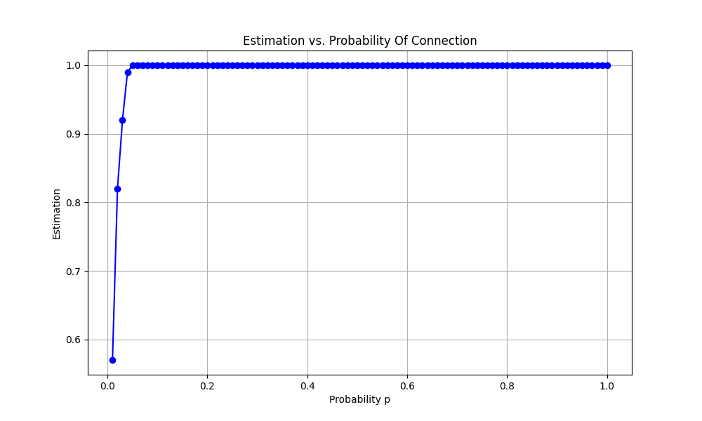

to estimate the probability we computed a case of $n$ drivers and $n$ riders where each driver could be connected to each rider with probability $p$, then we fixed the connections according to that $p$ to $0$ or $1$, and divided the size of the maximal matching by $p$.